**Title : Draw the Chess Board using Turtle In Python.**

**Description:**

Turtle library is used to design or images. Turtle is a python feature like drawing board, which let us command a turtle to draw all over it. It is a pre -installed library in python. So, just we need to import in our workspace. The python turtle library contain all methods and functions that are required to create designs and images.

We set a screen to draw chess board. We use turtle to show turtle on the screen by default it is arrow. Then we draw a small square and repeat it 8 times in a row and 8 times in columns. “i” represents rows and “j” represents columns. If (i+j)%2==0 then we use white color, else we use black color. We use color method to fill squares.

technologies: python programming language,turtle library

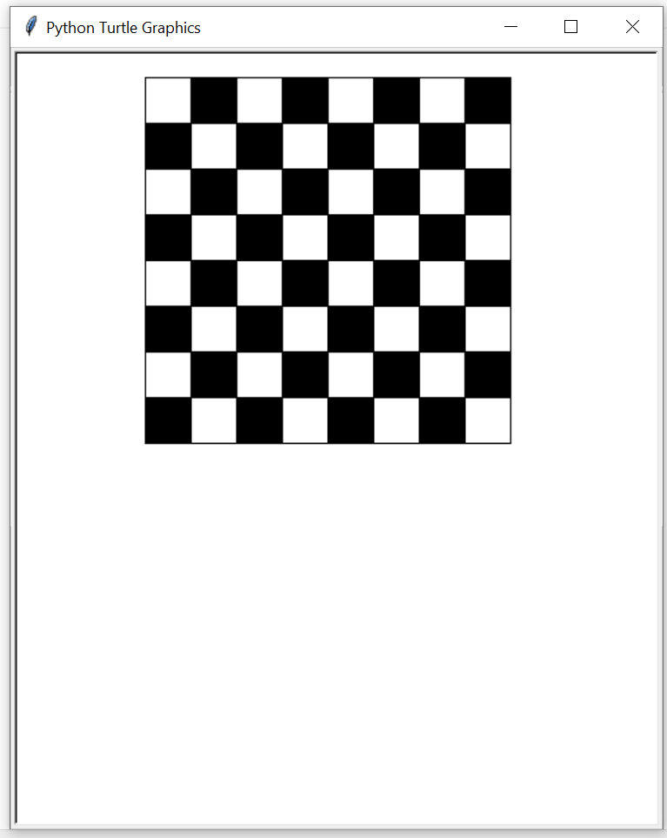

Source Code Link:

https://github.com/kartheekbasa/CHESS-BOARD.git